**DAILY ONLINE ACTIVITIES SUMMARY**

|  |  |  |  |  |  |  |  |  |
| --- | --- | --- | --- | --- | --- | --- | --- | --- |
| **Date:** | **11/06/2020** | | | | | **Name:** | **Lavanya D M** | |
| **Sem & Sec** | **4th & ‘A’** | | | | | **USN:** | **4al18cs041** | |
| **Online Test Summary** | | | | | | | | |
| **Subject** | | **nil** | | | | | | |
| **Max. Marks** | | **nil** | | **Score** | | | **nil** | |
| **Certification Course Summary** | | | | | | | | |
| **Course** | **VMware lab** | | | | | | | |
| **Certificate Provider** | | | **Bitdegree** | | **Duration** | | | **1 week** |
| **Coding Challenges** | | | | | | | | |
| **Problem Statement:1)** Write a Java Program to Segregate Even and Odd numbers  **2)**Write the java program to display 100 prime number | | | | | | | | |
| **Status: complied** | | | | | | | | |
| **Uploaded the report in Github** | | | | | **yes** | | | |
| **If yes Repository name** | | | | | <https://github.com/lavanyamurthi/lockdown-coding> | | | |
| **Uploaded the report in slack** | | | | | **yes** | | | |

Online Test Details: (Attach the snapshot and briefly write the report for the same)

Certification Course Details: (Attach the snapshot and briefly write the report for the same)

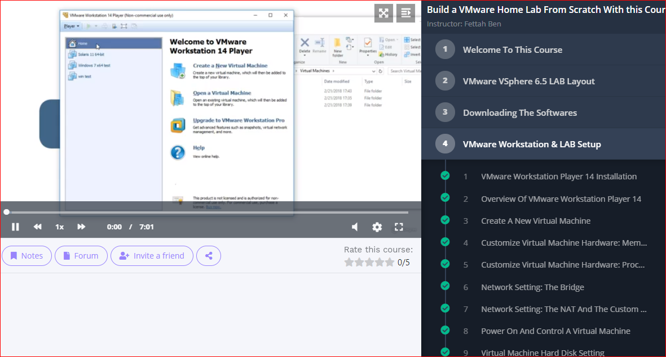

Coding Challenges Details: (Attach the snapshot and briefly write the report for the same)

Problem 1: Write a Java Program to Segregate Even and Odd numbers

Given an array A[], write a function that segregates even and odd numbers. The functions should put all even numbers first, and then odd numbers.  
Example:

Input = {12, 34, 45, 9, 8, 90, 3}  
Output = {12, 34, 8, 90, 45, 9, 3}

Algorithm: segregateEvenOdd()

1. Initialize two index variables left and right:  
   left = 0, right = size -1
2. Keep incrementing left index until we see an odd number.
3. Keep decrementing right index until we see an even number.
4. If lef < right then swap arr[left] and arr[right]

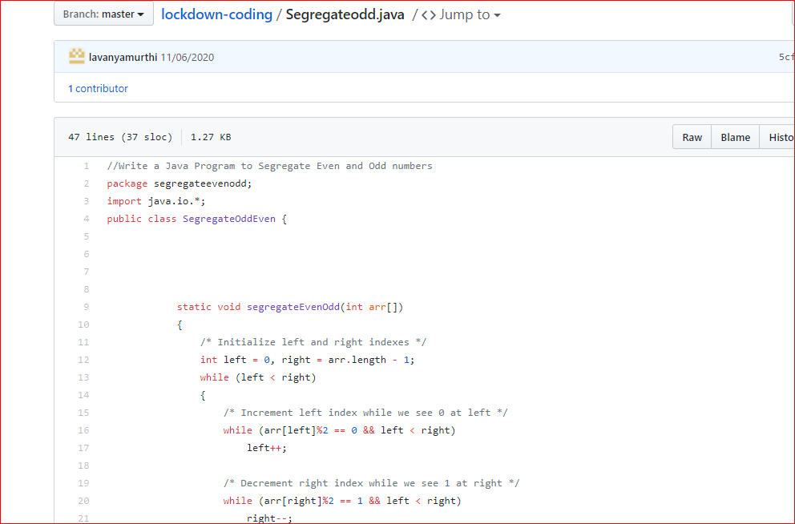

Problem 2: **Java program to print 100 prime number**

